Phase 4: Process Automation (Admin)
Validation Rules:
Healthcare: Ensure accurate patient data by restricting invalid entries, like birthdates in the future or missing allergy information.
Donation: Enforce correct donation details, like preventing negative pledge amounts or ensuring mandatory donor contact information is filled. Validation rules maintain data accuracy and compliance in both systems.

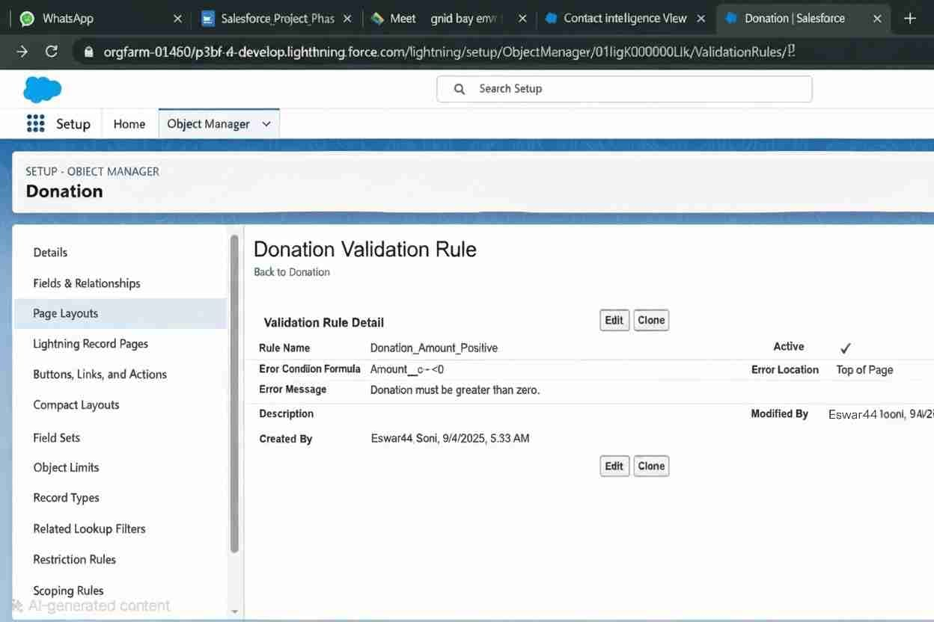

Workflow Rules:
Healthcare: Automate appointment reminders when a patient record is created or updated.
Donation: Send thank-you emails automatically when a donation is recorded. Workflow rules streamline repetitive tasks, improving communication and reducing manual effort in healthcare operations and donor management.
Process Builder:
Healthcare: Automate patient follow-up record creation when treatment status changes.
Donation: Automatically update donor status to “Active Supporter” after multiple contributions. Process Builder creates sophisticated, multi-step automation for managing healthcare processes and donor engagement workflows.
Approval Process:
Healthcare: Route treatment plan approvals to senior doctors before implementation.
Donation: Send large donations or grants for finance team approval. Approval processes enforce compliance, accountability, and oversight, ensuring critical actions receive proper authorization before execution.
Flow Builder (Screen, Record-Triggered, Scheduled, Auto-launched):
Healthcare: Screen flows collect patient intake details; record-triggered flows update treatment plans; scheduled flows send reminders; auto-launched flows assign follow-up tasks.
Donation: Screen flows guide volunteers in campaign setup; record-triggered flows update donor tiers; scheduled flows send pledge reminders; autolaunched flows assign campaign tasks.

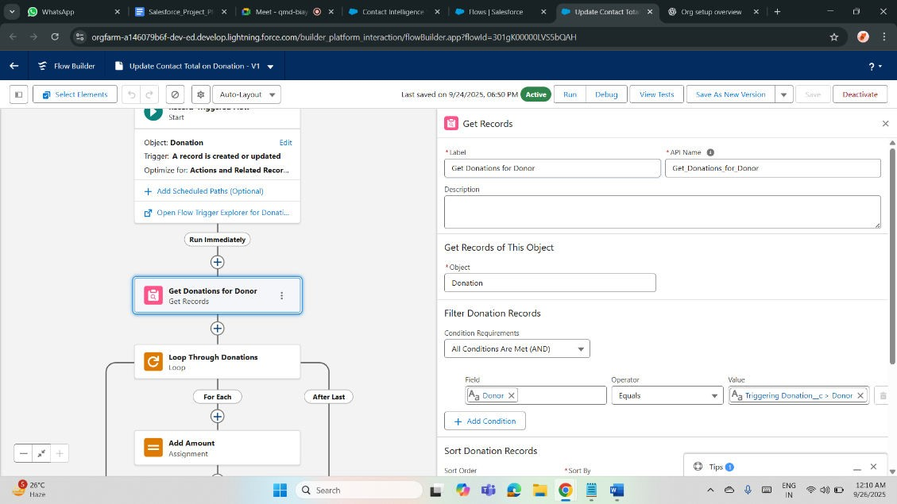
Email Alerts:
Healthcare: Automatically notify doctors of urgent patient test results. Donation: Send donors acknowledgment receipts and event invitations. Email alerts improve communication, ensuring stakeholders receive timely, consistent updates aligned with organizational needs.

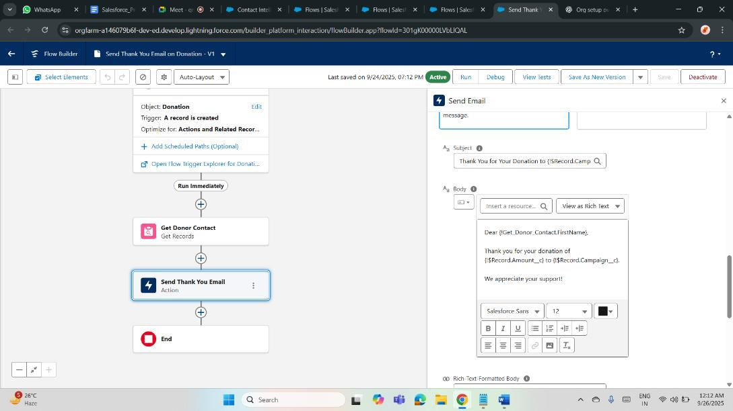
Field Updates:
Healthcare: Update patient status to “Discharged” after treatment completion.
Donation: Change donation record status to “Received” after payment confirmation. Automated field updates keep data current and eliminate manual record adjustments.
Tasks:
Healthcare: Create tasks for follow-up consultations, medication schedules, or lab result reviews.
Donation: Generate tasks for donor outreach, pledge follow-ups, or campaign activities. Task automation keeps teams organized and ensures accountability.
Custom Notifications:
Healthcare: Send push notifications to staff when a patient is admitted to emergency.
Donation: Notify fundraisers when a high-value donation is pledged. Custom notifications enhance responsiveness by alerting users instantly within Salesforce or on mobile apps.

